Brain Buster (Style Guidelines for Final Year Project ReportsQuiz Game)

Final Year Project Proposal

Session 2016-2020

A 4th Year Student

A project submitted in partial fulfilment of the

COMSATS University Degree

of

BSc. (Hons.)BS in Computer Science / Software Engineering (CUI)



Department of Computer Science

COMSATS University Islamabad, Lahore Campus

25 December 2019

**Project Registration**

|  |  |  |  |  |  |  |  |
| --- | --- | --- | --- | --- | --- | --- | --- |
| Project ID (for office use) | | |  | | | | |
| Type (Nature of project) | | | [ * ] **D**evelopment [ ] **R**esearch [ ] **R**&**D** | | | | |
| Area of specialization | | |  | | | | |
| **Project Group Members** | | | | | | | |
| Sr.# | Reg. # | Student Name | | CGPA | Email ID | Phone # | Signature |
| (i) | FA16-BCS-101 | Sohaib Ahmad | | 3.23 | [Fa16-bcs-101@cuilahore.edu.pk](mailto:Fa16-bcs-101@cuilahore.edu.pk) | 03336604232 |  |
| (ii) | FA16-BCS-249 | Muhammad Rizwan | | 2.63 | [Fa16-bcs-249@cuilahore.edu.pk](mailto:Fa16-bcs-249@cuilahore.edu.pk) | 03004671090 |  |
| (iii) | FA16-BCS-291 | Ali Ahmad | | 2.95 | [Fa16-bcs-291@cuilahore.edu.pk](mailto:Fa16-bcs-291@cuilahore.edu.pk) | 03069277078 |  |
| Name & Signature of Batch Advisor  (If students are eligible for FYP) | | | |  | | | |

# Plagiarism Free Certificate

This is to certify that, I am Sohaib Ahmad S/D/o Abdul Waheed, group leader of Semester Project under registration no CIIT/ FA16-BCS-101 /LHR at Computer Science Department, COMSATS Institute of Information Technology, Lahore.

Date: 25 December 2019 Name of Group Leader: Sohaib Ahmad Signature: _____________

Name of Supervisor: Ma’am Mamoona Tasadduq Co-Supervisor: Mr. Zaheer Ahmad Gondal

Designation: Lecturer, Computer Science Designation: Lecturer, Computer Science

Signature: _____________________ Signature: _____________________

**Approval of FYP Management Committee**

Committee Member 1: Name: _____________________

[ ] Accept [ ] *Defer [ ] *Reject Signature: _______________

*Remarks: _____________________________________________________________________

Committee Member 2: Name: _____________________

[ ] Accept [ ] *Defer [ ] *Reject Signature: _______________

*Remarks: _____________________________________________________________________

Convener: Name: _____________________

[ ] Accept [ ] *Defer [ ] *Reject Signature: _______________

*Remarks: _____________________________________________________________________

**Project Abstract**

Nowadays, e-learning and MOOCs (Massive Open Online Courses) are gaining a lot of attention. The students prefer to take online courses due to flexible timings and less cost. It has been observed, that many students drop out during the course. Lack of motivation is found to be the main reason due to which students leave the course. It is very important to keep the students engaged during the course and keep them motivated. By keeping this in view, we have proposed an e-learning application by combining all the useful, interesting and motivating factors of learning online by engaging in gamification process. “Brain Buster” is an application of personalized based learning with gamification[1] strategies. The students take quiz and the upcoming question is predicted while judging their response on previous questions. The difficulty level increase as they progress and they are rewarded with points and badges. All track records are saved thus motivating the student to complete daily tasks like attempting quiz regularly, continuous logins in a week and much more. While completing these tasks they will earn multiple badges. A discussion forum will be provided to the students to collaborate and resolve queries related to course, which will improve their learning concept. Students can also view their competitors and their standing among others using leader-board. Including some other gamified features, this quiz game will help students to improve their knowledge and get excellence in their domain.

**Introduction**

The quiz project is an application of personalized learning[2], in which the learning experience is different for every student. The process used throughout our project is gamification, by which we will use game design elements in a non-game context. This quiz project will enhance the ability of students to overcome challenges, arouse curiosity within them to explore further challenges and help them in learning new concepts.

The features upholding our project are described as under.

* Students can take a quiz based on different difficulty levels. The machine will decide whether a student qualifies for the next difficulty or not. After every level, a rapid-fire round starts which will review most of the concepts learned by previous completed round.
* Students can upload queries with specific tags (e.g., if/else, for loop, etc.) in the discussion forum and they will be categorized in forum according to their tags. Students will collaborate to answer the queries which will improve their learning concept.
* Students progress through different levels which will increase in difficulty as their skills improve. Each level has multiple stages.
* Students' track record including earned points and number of days practiced in a row, will be maintained to encourage students to return every day.
* A Feedback system is provided to students to take a review of the type of problems they are facing in the series of questions.
* Students will have a badge, representing their rank within the quiz game. There will be several optional badges as well, which will be given to the students as they will complete challenges related to that badge e.g., if students login daily for a month, they will receive a badge of a regular student.
* Students will earn rewards as they progress throughout the game.
* A leader board will be displayed to all students to view their standing, among others.
* Daily and weekly challenges can also be added depending on the availability of time. Students will receive some optional challenges daily and weekly and receive points based on these challenges e.g. for the daily challenge there can be a challenge as helping one person in the discussion forum and for the weekly challenge, there can be as help five people in a week in the discussion forum.
* Students can challenge their online friends for a rapid-fire challenge. There will be ten questions, and sixty seconds will be provided for each question to solve. The wrong answer will deduct one mark and the right answer will increase one mark. One who solves all questions first with a greater number of points wins.

During the project, the students will undergo such activities, which will increase the motivation of students and engage them in interesting activities. It may help in the retention of students towards educational activities.

**Motivation and Scope**

Many apps and games used in our daily life use gamification. People are fond of games in which they earn 3 stars. This idea of rewarding users motivates us to implement in the learning process. The student gets to learn new concepts by playing an interesting educational quiz game. This product has a very wide scope as everyone loves getting points by a little effort, then why not getting points by learning your syllabus.

**Related Work**

‘Duolingo’[3] is a web application that works on the concept of personalized learning and gamification. This platform trains its user to learn multiple languages. It awards them with badges and rewards and takes feedback. A leader board is also present for user ranking within the game.

Another application is ‘Quizizz’[4]. In this application teacher from worldwide made quizzes related to many subjects and they are ready to play. Students can take a quiz to learn the concept of some topics. They can challenge their friends and their game record is saved. But there is no classroom environment like in our project. We will provide a class enrolment system that is monitored by the specific teacher and class performance is recorded.

There is an application called ‘Khan Academy’[5]. It is totally free and provides video lectures for multiple concepts. The student learns one concept and moves on to the other. Not much gamification is found in it.

Our work is related to these applications, we are using this process for learning the purpose of some academic syllabus of specific monitored class via a quiz.

**System Architecture**

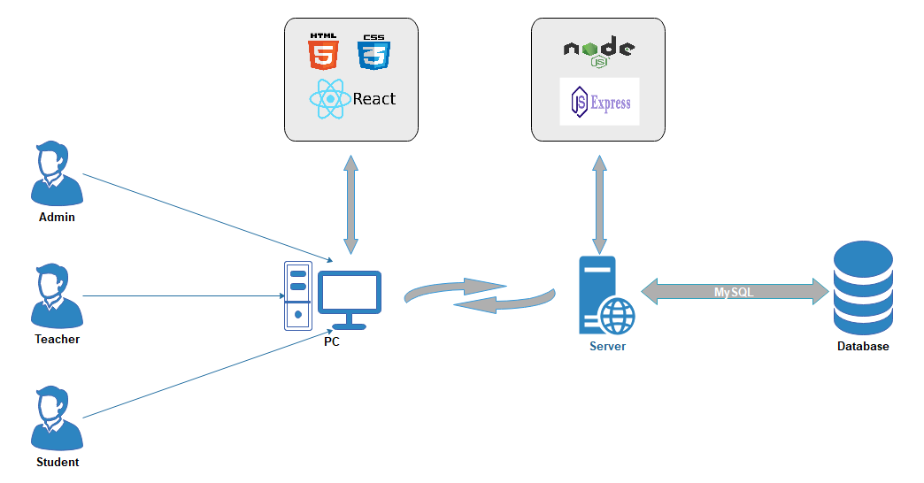

**Goals and Objectives**

Our goal is to engage students in learning activities, which improve their knowledge and skills and helps in the brainstorming process. Most of the students don’t like to watch lengthy video tutorials, they want a short solution to every problem, so this quiz game will help them by going through every key point of related topic arranged in multiple difficulty levels.

**Individual Tasks**

Sohaib Ahmad (Backend development, Database)

Muhammad Rizwan (Frontend design and development, Reporting)

Ali Ahmad (Frontend development, Database)

**Gantt Chart**

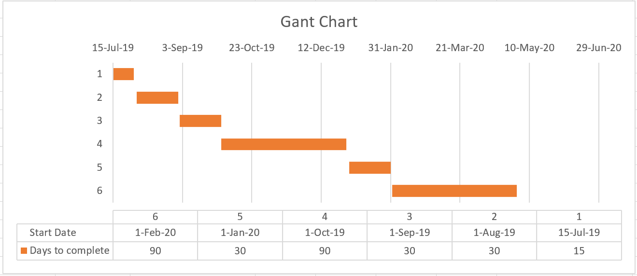

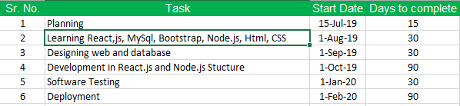

**Future Work**

Our project is limited to a specific course, it can be enhanced by adding different study programs and multiple courses maintained by multiple teachers.

**Tools and Technologies**

The following are the tools and technologies we will use during our project.

* React.js
* MySQL Database
* Node.js
* Express
* HTML5
* CSS3
* Visual Studio code
* SQL server management studio

Project scope and technologies can be enhanced depending on the availability of time.

**References**

* <https://www.duolingo.com/>
* <https://quizizz.com/>
* <https://www.khanacademy.org/>
* <https://en.wikipedia.org/wiki/Gamification>
* <https://www.understood.org/en/school-learning/partnering-with-childs-school/instructional-strategies/personalized-learning-what-you-need-to-know>
* <https://en.wikipedia.org/wiki/Personalized_learning>

Appendix A

*Include here the 1st page of Turnitin Report*

Every supervisor has his/her own Turnitin account. If not then supervisors are requested to get the account from Library as soon as possible.

1. <https://en.wikipedia.org/wiki/Gamification>
2. <https://en.wikipedia.org/wiki/Personalized_learning>
3. <https://www.duolingo.com/>
4. <https://quizizz.com/>
5. <https://www.khanacademy.org/>